This form must be completed and submitted by **all teams no later than the date specified in the Action Deadlines on specific event website**. The FSAE Technical Committee will review all submissions which deviate from the FSAE® rulesand reply with a decision about the requested deviation. All requests will have a confirmation of receipt sent to the team.Impact Attenuator Data (IAD) and supporting calculations must be submitted electronically in Adobe Acrobat Format(*.pdf). The submissions must be named as follows: schoolname_IAD.pdf using the complete school name. **Submit the IAD report as instructed on the event website. For Michigan and Lincoln events submit through fsaeonline.com.**

*In the event that the FSAE Technical Committee requests additional information or calculations, teams have **one week from the date of the request** to submit the requested information or ask for a deadline extension.

University Name: ____Yale Univeristy_____ Car Number: ________________E228__________

Team Contact: ___Taha Ramazanoglu______ E-mail Address: _____taha.ramazanoglu@yale.edu______

Faculty Advisor: _______Joseph Zinter_____ E-mail Address:_____joseph.zinter@yale.edu_________

|  |  |
| --- | --- |
| Material(s) Used | Aluminum |
| Description of form/shape | Honeycomb 5052 5.7pcf 3/16” 4”x8”x10.7” |
| IA to Anti-Intrusion Plate mounting method | WEST SYSTEM® Six10® Thickened Epoxy Adhesive |
| Anti-Intrusion Plate to Front Bulkhead mounting method | 4, 5/16 Grade 8 Bolts |
| Peak deceleration (<= 40 g's) | 18.8 g’s |
| Average deceleration (<= 20 g's) | 16.3g’s |

Confirm that the attenuator contains the minimum volume 200mm wide x 100mm high x 200mm long

**X**

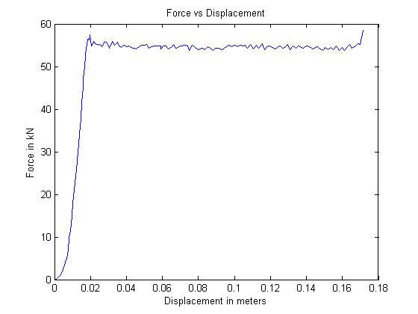

Figure 1: Force-Displacement Curve (dynamic tests must show displacement during collision and after the point v=0 and until force becomes = 0)

**ATTACH PROOF OF EQUIVALENCY**

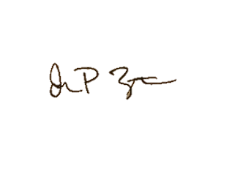TECHNICAL COMMITTEE DECISION/COMMENTS

_______________________________________________________________________________________

Approved by_________Joseph Zinter_____________________________ Date_______2/5/16______

**NOTE: THIS FORM AND THE APPROVED COPY OF THE SUBMISSION MUST BE PRESENTED**

**AT TECHNICAL INSPECTION AT EVERY FORMULA SAE EVENT ENTERED**

University Name: __Yale University_______ Car Number(s) & Event(s): _E228: FSAE Electric__

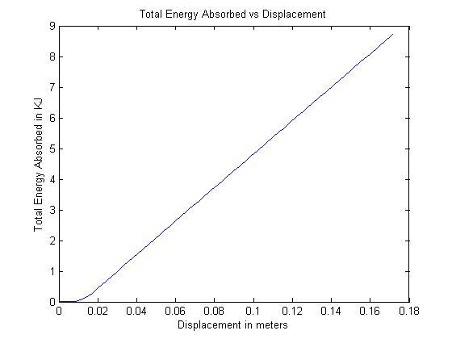

Figure 2: Energy-Displacement Curve (dynamic tests must show displacement during collision and after v=0)

|  |  |  |
| --- | --- | --- |
|  |  |  |

Figure 3: Attenuator as Constructed Figure 4: Attenuator after Impact

*See appended photos for Anti-intrusion plate deformation measurement

|  |  |  |  |
| --- | --- | --- | --- |
| Energy Absorbed (J):  Must be >= 7350 J | 8,720 | Vehicle includes front wing in front of front bulkhead? | Yes/**No** |
| IA Max. Crushed Displacement (mm): | 171.5 | Wing structure included in test? | N/A |
| IA Post Crush Displacement - demonstrating any return (mm): | -18.0 | Test Type: (e.g. barrier test, drop test, quasi-static crush) | Quasi-static crush |
| Anti-Intrusion Plate Deformation (mm) | 9 | Test Site: (must be from approved test site list on website for dynamic tests) | Yale University, Schroers’s Lab  Instron 5569 |

University Name: __Yale University_______ Car Number(s) & Event(s): _E228: FSAE Electric__

Test Data Calculations:

The Rules require that our impact attenuator, “when mounted on the front of a vehicle with a total mass of 300 kg (661 lbs.) and run into a solid, non-yielding impact barrier with a velocity of impact of 7.0 meters/second (23.0 ft/sec), would give an average deceleration of the vehicle not to exceed 20 g’s, with a peak deceleration less than or equal to 40 g’s. Total energy absorbed must meet or exceed 7350 Joules.”

**Weight:**

We estimate our vehicle will have a mass of mass of about 683 lbs. As this weight is greater than the 300 kg weight specified in the rules, we will show calculations for both the hypothetical 300kg vehicle and our 683 lbs (309 kg) vehicle when the weight is rounded off to the next one-hundred (i.e., 700 lbs or 317.5 kg).

**Peak deceleration:**

Our compression testing yielded a maximum force of 58.5 kN. Generally, acceleration may be calculated as:

$$1. a=F/m$$

For a Force “F” and Mass “m”

*Case 1: m=317.5 kg*

For our mass of 317.5 kg, equation 1 yields a maximum acceleration:

$$a_{max}=\frac{F_{max}}{m}=\frac{58,500N}{317.5 kg}=184.3\frac{m}{s^{2}}=18.8 g^{'}s$$

*Case 2: m=300 kg*

For a mass of 300 kg, this yields

$$a_{max}=\frac{F_{max}}{m}=\frac{58,500N}{300 kg}=195\frac{m}{s^{2}}=19.9 g^{'}s$$

In both cases, amax < 40 g’s.

**Average deceleration:**

We used Matlab to calculate a displacement-averaged-force of 50.7 kN over our testing curve. For each displacement unit, we multiplied the differential displacement by the average force over that distance. Finally, we summed each of these products and divided by total displacement to generate a total average force.

*Case 1: m=317.5 kg*

For our mass of 317.5 kg, this yields an average acceleration:

$$a_{average}=\frac{F_{average}}{m}=\frac{50,700 N}{317.5 kg}=159.7.3\frac{m}{s^{2}} {=16.3 g}^{'}s$$

University Name: __Yale University_______ Car Number(s) & Event(s): _E228: FSAE Electric__

*Case 2: m=300kg*

For a mass of 300 kg, this yields

$$a_{average}=\frac{F_{average}}{m}=\frac{51,200 N}{300 kg}=170.7\frac{m}{s^{2}}=17.4 g^{'}s$$

In both cases, aaverage < 20 g’s.

**Total Absorbed Energy:**

The Rules require that our impact attenuator decelerate our vehicle from 7 m/s, absorbing more than 7,350 Joules.

Generally, work done on a system at is given by:

$$3. W=F*D$$

for a force “F”, over a distance “D”.

Thus, for a Force vs. Displacement curve, the work done on the attenuator is equivalent to the area under the curve. By conservation of energy, this total work is equivalent to total absorbed KE. We used Matlab to approximate this area as a sum of trapezoidal areas. For our total test displacement of 0.17 meters, we calculated:

Total Energy absorbed = 8,720 Joules

At 317.5 kg, our vehicle has Kinetic Energy given by:

$$2.KE=\frac{1}{2}mv^{2}=\frac{1}{2}\left(317.5 kg\right){\left(7\frac{ m}{s}\right)}^{2}=7,779 Joules.$$

And 8,720J > 7779J > 7350J, so we can absorb enough energy.

University Name: __Yale University_______ Car Number(s) & Event(s): _E228: FSAE Electric__

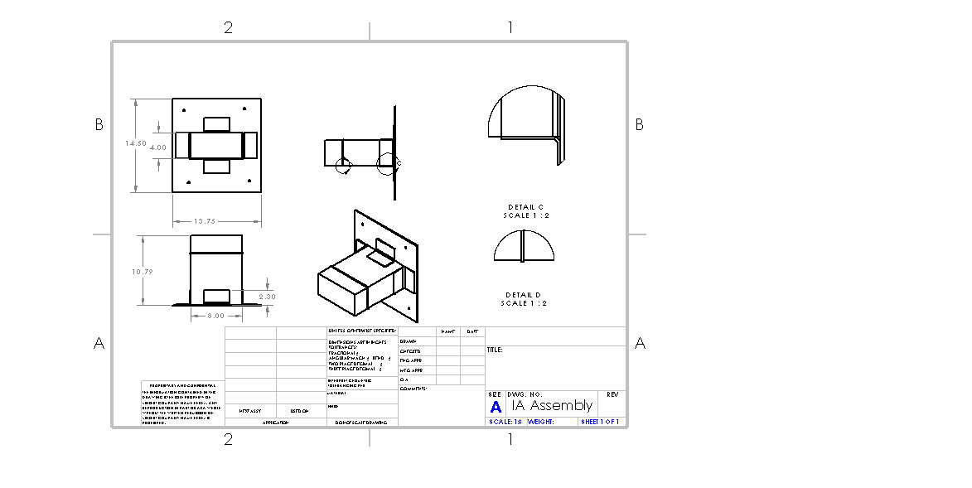

See attached drawings for improved size and quality.

Length (fore/aft direction): __274.1_ mm (>=200mm)

Width (lateral direction): _203.2__ mm (>=200mm)

Height (vertical direction): __101.6_ mm (>=100mm)

Attenuator is at least 200mm wide by 100mm high for at least 200mm: **Yes**/No

***Attach additional information below this point and/or on additional sheets***

Test schematic, photos of test, design report including reasons for selection and advantages/disadvantages, etc. Additional information shall be kept concise and relevant.